Classification of Disaster Tweets using NLP

Team: Manasa Hari, Amit Kamboj, Feiyu Cai, Tushar Sharma

**Abstract** — Twitter has been the most important part of digital communication these days. It has been the channel of communication across the world for daily news starting from television gossips to case-of-emergency news. But due to large amounts of data flooding into the twitter base every minute, sometimes, a highly important piece of news such as a disaster occurrence can be submerged amidst not at all important tweets. Due to this, it may take days or even weeks before the disaster news reaches to people, meanwhile, a huge irrevocable loss can happen already. This project aims to highlight the disaster emergency news so that users can be constantly notified on the emergency issues out of millions of other tweets. We take the challenge to build a machine learning model that classifies between tweets about real disasters and the rest. The key challenge is to distinguish metaphorical usage of tragedy vocabulary and the real intended usage of disaster terms. For example, a user tweets ‘Thoughts are a storm, unexpected’. This is clearly a metaphorical statement. Even though it is obvious for humans to interpret that this tweet is not about a real disaster, but it is less clear to a machine. This problem is also an actively ongoing Kaggle competition. We want to explore possible predictors and conclude on the right predictors to solve this classification problem. The dataset has 10,000 tweets that were hand classified[1]. We will explore Naïve Bayes, LSTM and CNN classifiers to solve this problem.

1. **Introduction**

This report describes the step by step process of building a recurrent neural network (RNN) that classifies tweets to one of two potential classes: Disaster related tweet or Not Disaster related tweet. A basic implementation of a Long Short-Term Memory Network (LSTM) along with a specialized embedding matrix is used in this method. We also explored the variation of test score with input batch size and optimization iterations in this process. We also used a 10-fold cross validation logistic regression with bag of words model which was modified to classify the tweets. This attributes to the inherent ’features’ that the models emphasize.

1. **Literature review and Related work**

In this project, our goal is to make a classification that predicts is the tweet disaster or not. We chose to use neural networks over other classifiers for this project regarding our data input is going to be English words that are way more complicated than just numbers and word of characteristics. Different sentence structures and context can make the same word have different meanings. According to Shamina and Banerjee state in the article Improved Speech Inversion Using General Regression Neural Network, “It was shown that a three-layered feedforward neural network (NN) can perform better speech inversion than trajectory mixture density models, support vector regression, autoregressive NN, and distal supervised learning.” For this reason, we decided to use the neural network, which is very effective for high dimensionality problems, able to deal with complex relations between variables, non-exhaustive category sets, and complex functions relating input to output variables. Here is an example given by Finch and Schneider in Classification accuracy of neural networks vs. discriminant analysis, logistic regression, and classification and regression trees: Three- and five-group cases when comparing NN with common regression “If, for example, two variables interact and none of the others play a role, then the hidden layer would be represented by large weights for each of the two and near 0 weights for the others. On the other hand, a hidden layer could be thought of as the combination of several of the predictors with some contributing slightly more and, thus, having slightly larger weight values.” The strengths of NN is creating a hidden layer that contained nodes as weighted products of variables while expressing the interactions among the predictor variables.

With all the neural network methods, we chose the Recurrent Neural Network (RNN) with Long Short-Term Memory (LSTM) for this project. According to Hsu, Zhang, and Glass state in the paper A prioritized grid long short-term memory RNN for speech recognition that “Recurrent neural networks (RNNs) are naturally suitable for speech recognition because of their ability of utilizing dynamically changing temporal information.” First of all, RNN is a generalization of feedforwarding neural network that has an internal memory, which means RNN performs the same function for every input of data with the output of previous outputs. After every computation, the output is copied and sent back into the RNN function internal state (memory). For this reason, this characteristic makes it better for speech recognition while all inputs are related to each other.

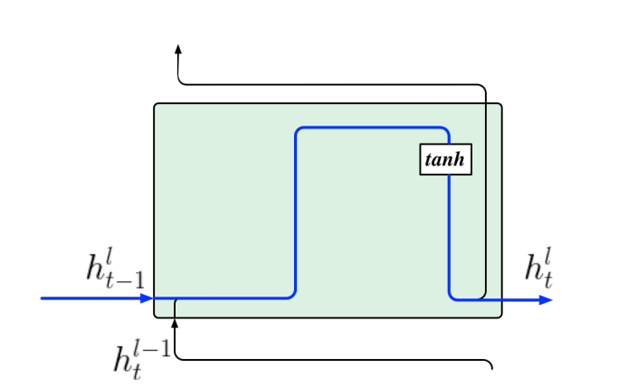

Figure 1: RNN block model

However, the internal state cannot last forever. RNN has gradient vanishing while the process takes too long. Gradients are values used to update neural network weights, which will shrink during back-propagation. When the gradient becomes too small, it doesn't contribute to the learning process. So, we use LSTM to resolve this problem. LSTM is a modified version of RNN, which improved in remembering past data in memory. According to Hsu, Zhang, and Glass state in the paper A prioritized grid long short-term memory RNN for speech recognition that “…more importantly, a gated linear dependence is introduced between memory cell states across two consecutive time steps which allows memories to be preserved.” LSTM uses back-propagation to train the model within the LSTM's cell which is better when classify, process, and predict time series given time lags of unknown duration. In each LSTM cell model, 3 gates presented to help to decide what information to keep or throw away:

* Forget gate: used to decide what detail can be discarded from the block
* Input gate: used to decide which input should be used to modify the memory
* Output gate: used to calculate the cell state

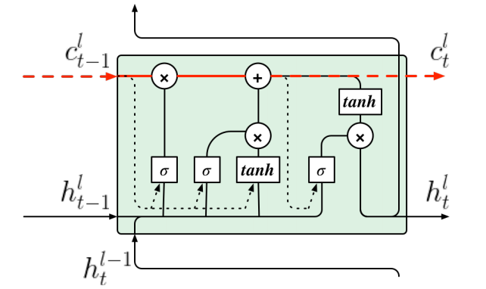

Figure 2: LSTM block model

1. **Project Architecture**

Supervised learning – classification problem:

This problem is clearly a classification algorithm. It has only two classes (Class 1 – represents that is a disaster identified tweet and Class 0 – represents that is not a disaster tweeted about). Since, we are provided with the known labels in the training set, this is considered as a supervised problem. So, in total, we call this problem as a supervised classification problem.

We want to build a model of these examples, then use that model to make predictions. Hence, this is model-based learning.

We are going to follow six major steps in this project:

1. Study the data
2. Data pre-processing
3. Develop a model for the data
4. Train the model on the training data
5. Finally, apply the model to make predictions on new cases (inference)
6. In this process, we strive for better accuracy and hope that this model will generalize well. We will fine-tune the model, while studying the data.

**Step 0: Setting up the environment and libraries:**

We used Jupyter notebook for this project.

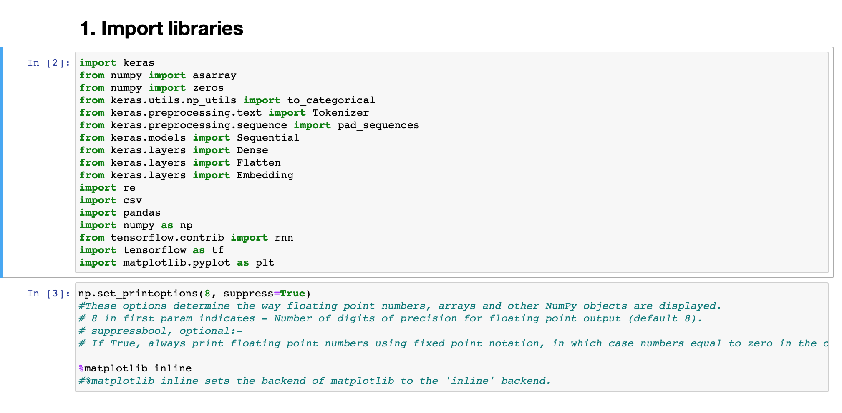

**Step 1: Study the data**

We got the dataset from Kaggle.com. <https://www.kaggle.com/c/nlp-getting-started/data>

The given data comprises of train.csv and test.csv. We are supposed to study the data and discover a model using. Below are the steps to load the data.

Each sample in the train and test set has the following information:

1. id - a unique identifier for each tweet
2. text - the text of the tweet
3. location - the location the tweet was sent from (may be blank)
4. keyword - a particular keyword from the tweet (may be blank)
5. target - in train.csv only, this denotes whether a tweet is about a real disaster (1) or not (0)

Here, the given datasets are 1) train.csv and 2) test.csv files.

Train.csv:-

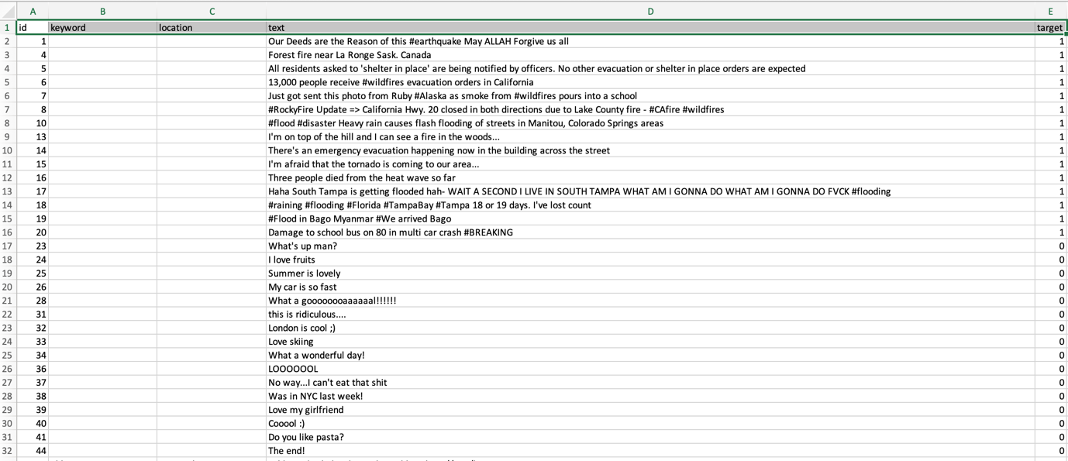

Test.csv:-

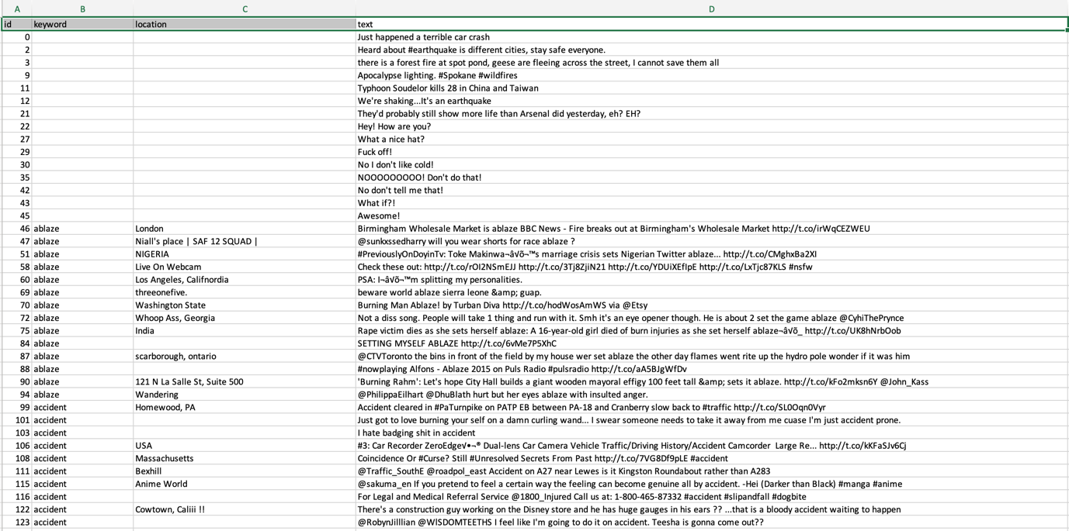

As seen above, there are some hyperlinks in the data. So, there is a necessity of removing the hyperlinks to clean up the data. In this data cleaning process,

**Step 2: Data Pre-processing**

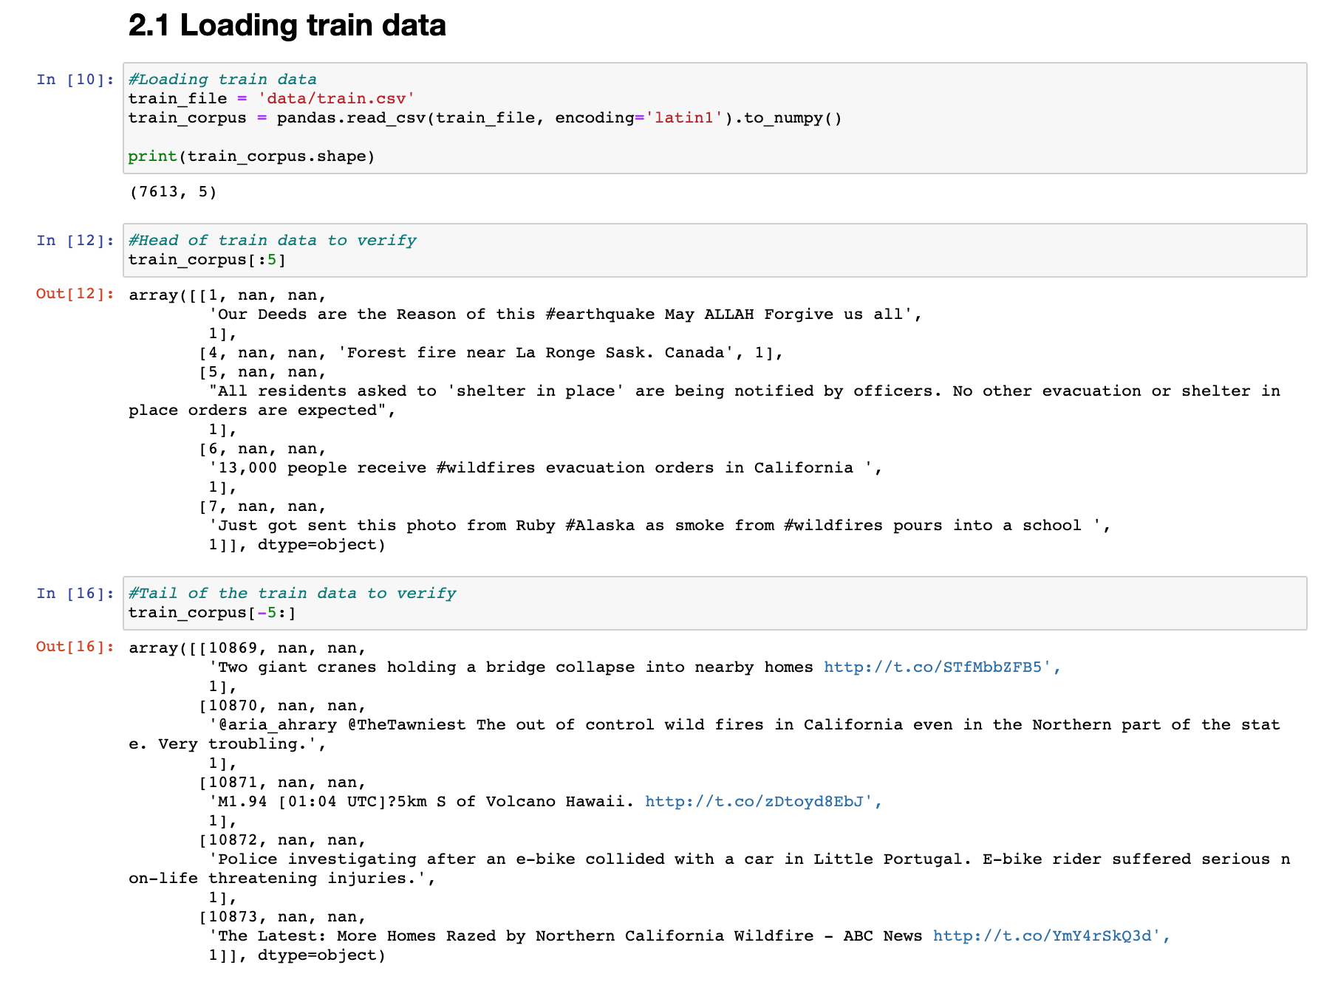

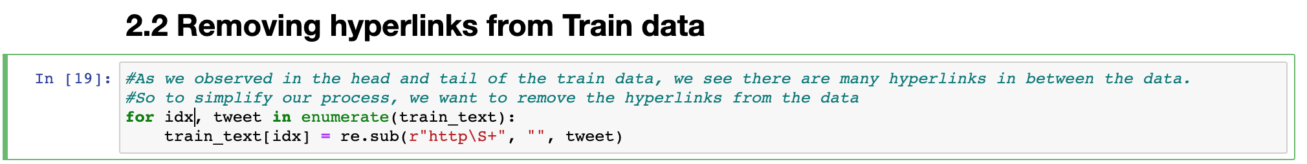

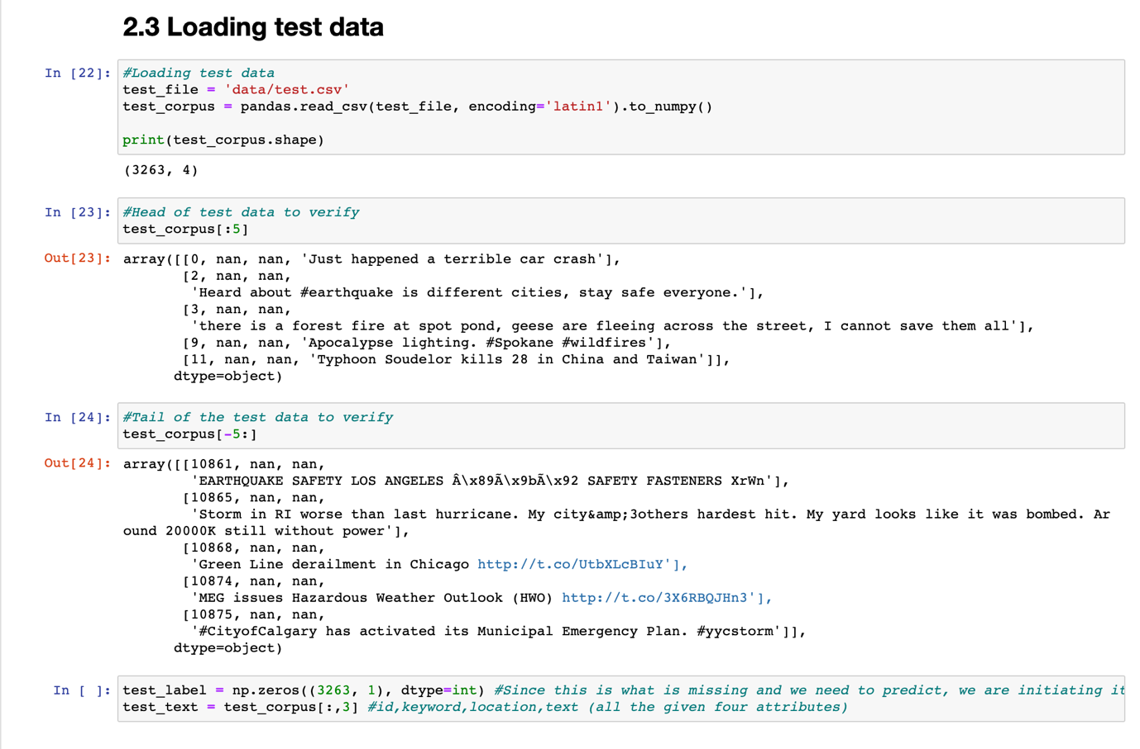

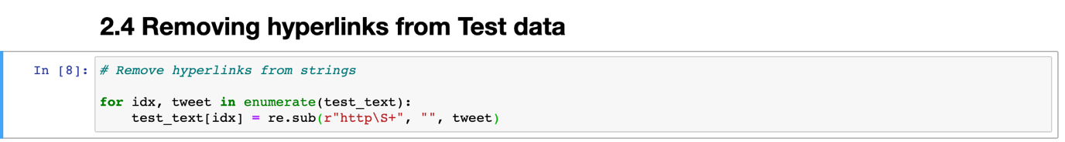

Important notes:

Normally, we perform the following operations too in a typical machine learning problem.

1. Feature scaling
2. Data visualization to gain insights
3. Regularization

Since this is a tweet classification problem using NLP, and given are string features, we would not do these above specified three operations.

**Step 2.5: One hot encoding**

ML algorithms usually assume that two nearby numbers have more similarity than two distant values. This can be okay in some cases like text labelled like: good, bad, worst, excellent categories. But it does not make sense in 0,1,2,3,4 categories. A simple fix to this problem is to create a binary attribute per category.

That is, when this attribute is equal to 1, it belongs to a particular category. If it does not belong that category, the attribute is set to 0.

This is called **One-hot encoding**. In this type of encoding, only one attribute will be 1 (hot), while the others will be 0 (cold).

We used to_categorical from keras.utils.np_utils library to do this operation.

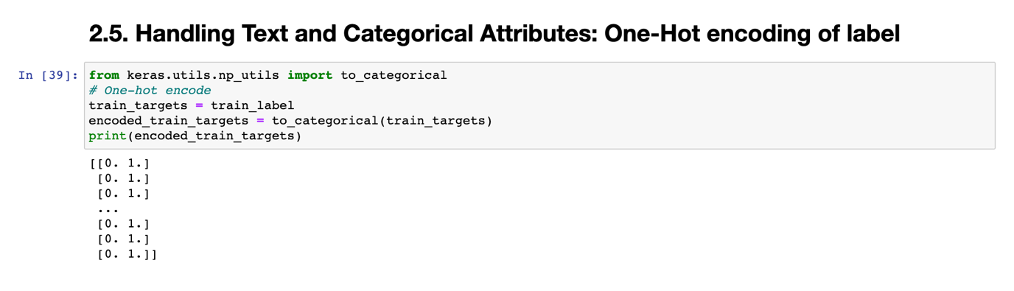

We could see that now, two *dummy* attributes created. Only one of them will be representing the real category. Here, the number of *dummy* columns created is equal to the number of classes represented by the target column.

As an added step, we also built a reverse encoder to later convert the one-hot encoded values to the original required target values.

**Step 2.6: Reverse Encoder**

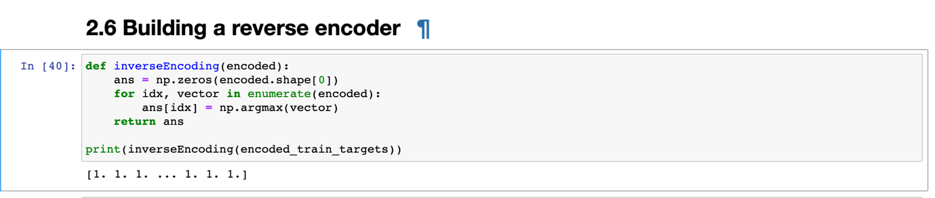

**Step 2.7: Tokenizer – Hash encoding**

We did research on different encoding techniques provided by Keras.

Why we need to encode a document:

Raw data cannot be fed directly into machine learning models. Text data must be encoded as numbers to use as input or output in a machine learning model.

In this project, we explored the path of encoding text using Keras library.

As a first step, we split the text into words using text_to_word_sequence() function.

By default, this function does 3 things as below: [4]

1. Splits words by space (split=” “).
2. Filters out punctuation (filters=’!”#$%&()*+,-./:;<=>?@[\\]^_`{|}~\t\n’).
3. Converts text to lowercase (lower=True).

**Step 2.7: Tokenizer - Text pre-processing with Keras**

One of the most sophisticated methods provided by Keras API is the Tokenizer class. It not only is used to prepare the text to fit, but also can be reused to prepare multiple other text documents. This API also supports large datasets.

We first need to construct this Tokenizer class and then use it to fit our raw text. We create the constructor of this class using the following code snippet:

Code: t = Tokenizer()

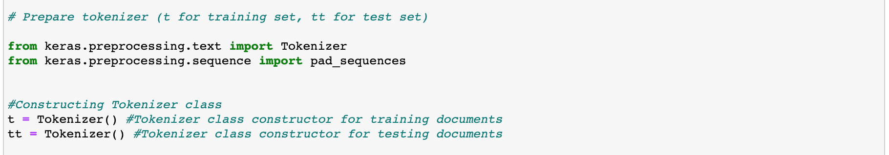

Once we created the constructors, we fit the documents as below.

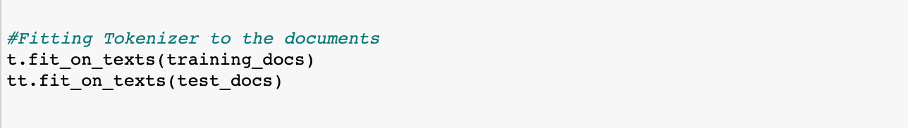

In the following, we can observe what was learnt about the data using Tokenizer.

Tokenizer class’s fit provides the below four attributes: [4]

1. word_counts: A dictionary of words and their counts.
2. word_docs: A dictionary of words and how many documents each appeared in.
3. word_index: A dictionary of words and their uniquely assigned integers.
4. document_count:An integer count of the total number of documents that were used to fit the Tokenizer.

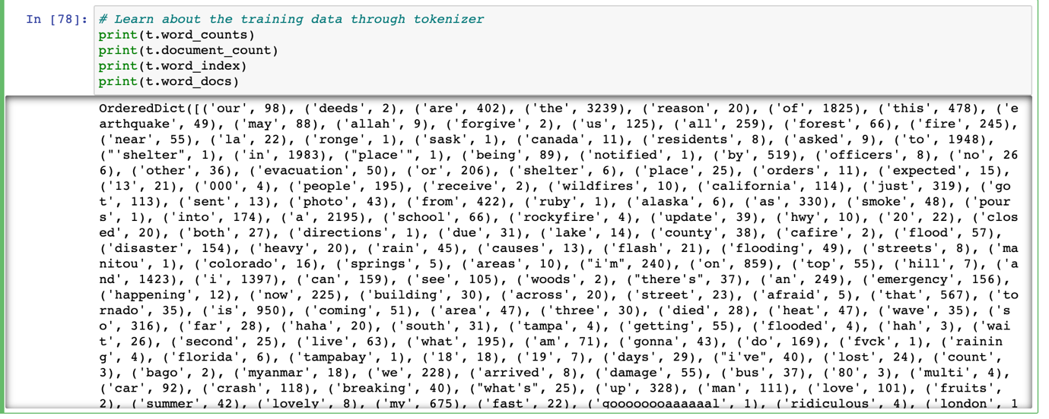

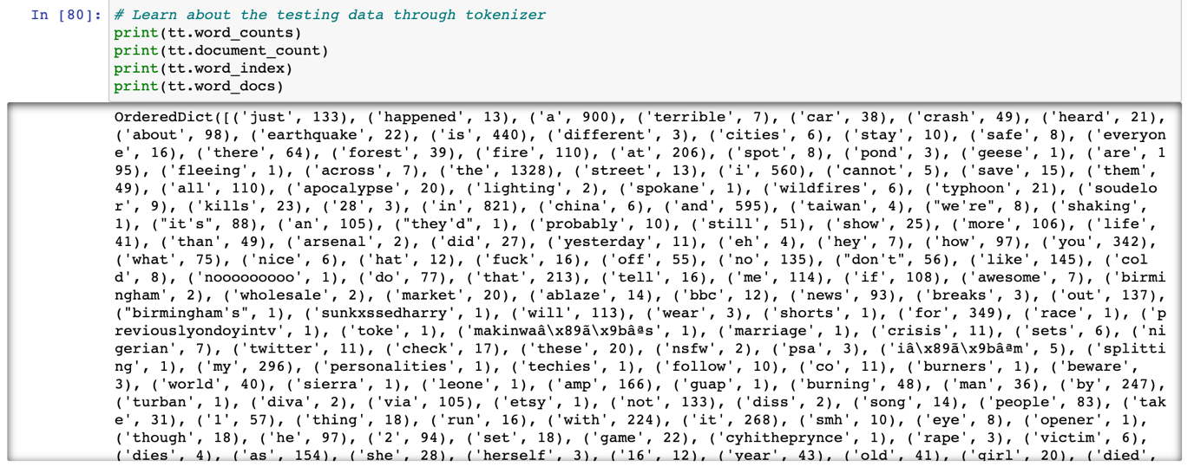

We used variable length tokenization here. We used Keras library for creating a vector of works in every tweet. The vectors are padded up to 50 (here, as we defined), to be the limit of number of possible words in a 140-characters length sized tweet.

We considered approximately, 150/50 = 3 characters per word (which includes a space). Below is how we performed integer encoding to both the training and testing documents.

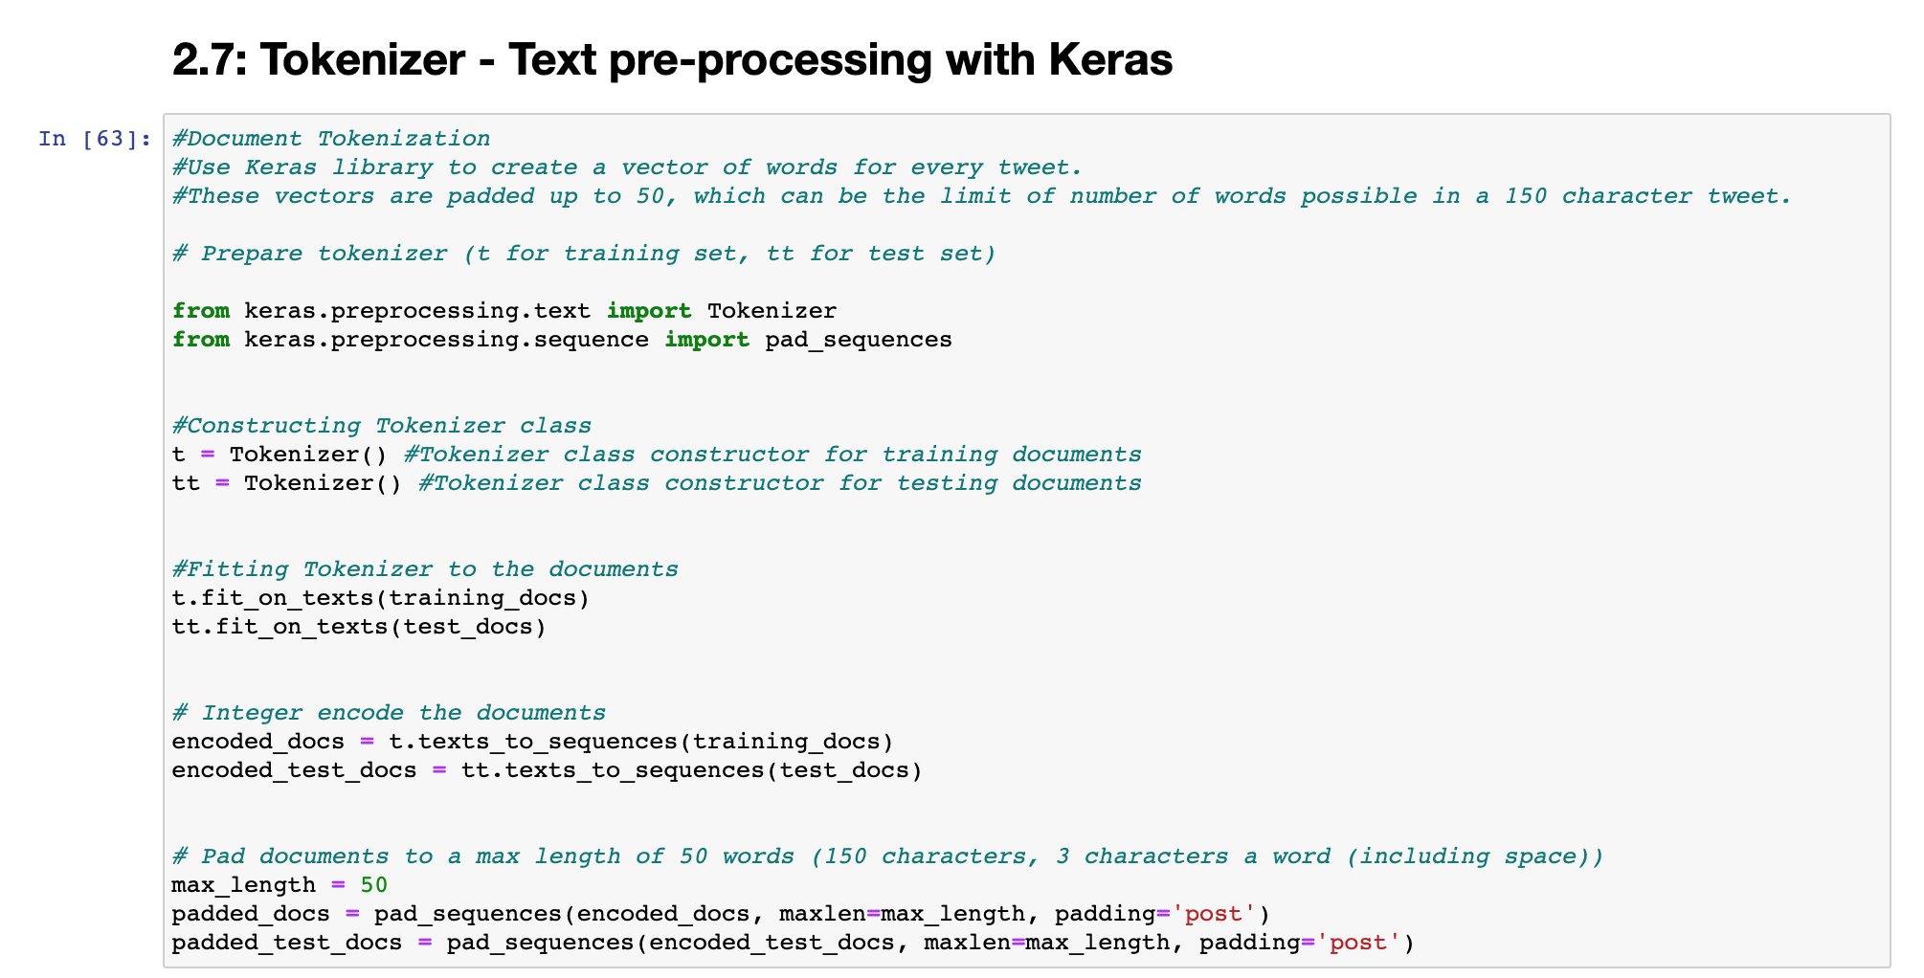

Now, we are completed with the data pre-processing step. We will now look into building the model for this data.

**Step 3: Develop a model for the data**

We explored different models for this problem initially. After a long exploration, we found RNN (Recurrent Neural Networks) work better. RNNs are a class of neural networks that can predict based on input sequences of arbitrary lengths, rather than fixed sized inputs, unlike other nets. That means, they can take sentences, documents etc. as inputs to predict the targets. And that is why, they are extremely useful for natural language processing (NLP).

* 1. **Word Embedding**

We used GloVe’s 50d word vector, which is pre-trained on 2 billion tweets, for the embedding matrix. This matrix reports the frequency of each word co-occurring with another one from the given set. We chose the widely popular GloVe’s pre-trained matrix for this work. We also chose a 50-dimension matrix to be a balance between speed of the process and embedding quality.

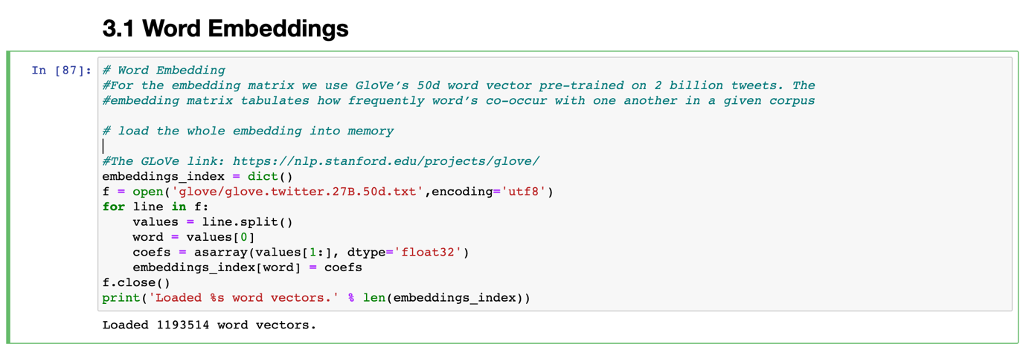

We used the glove ‘glove.twitter.27B.50d.txt’ from the source <https://nlp.stanford.edu/projects/glove/>. [5]

Natural Language Processing:

Most of the state-of-the-art NLP applications, such as machine translation, automatic summarization, parsing, sentiment analysis, and more, are now based (at least in part) on RNNs. [6]

**3.2 Design the Neural Network**

We want to use several Epochs in this process. In neural networks, an epoch refers to one cycle through the full training set. We used batch based training approach in which, we run each epoch to make a prediction per batch.

The below diagram represents how we use LSTM in this project.

Diagram idea: Represent LSTM of our project

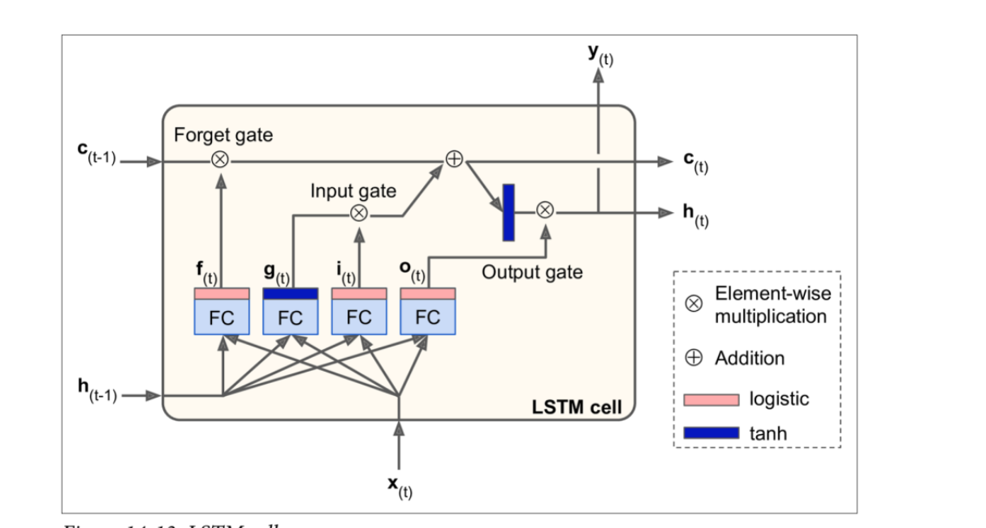

Diagram source: References [7]

1. Step: Defining parameters
2. Number of classes in output : 2



1. Maximum number of words in each tweet and Timesteps : 50





1. LTSM units and batch size : 128

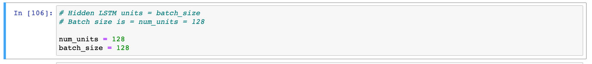

1. Adam’s optimizer’s learning rate : 0.001



Below are the steps to run LSTM.

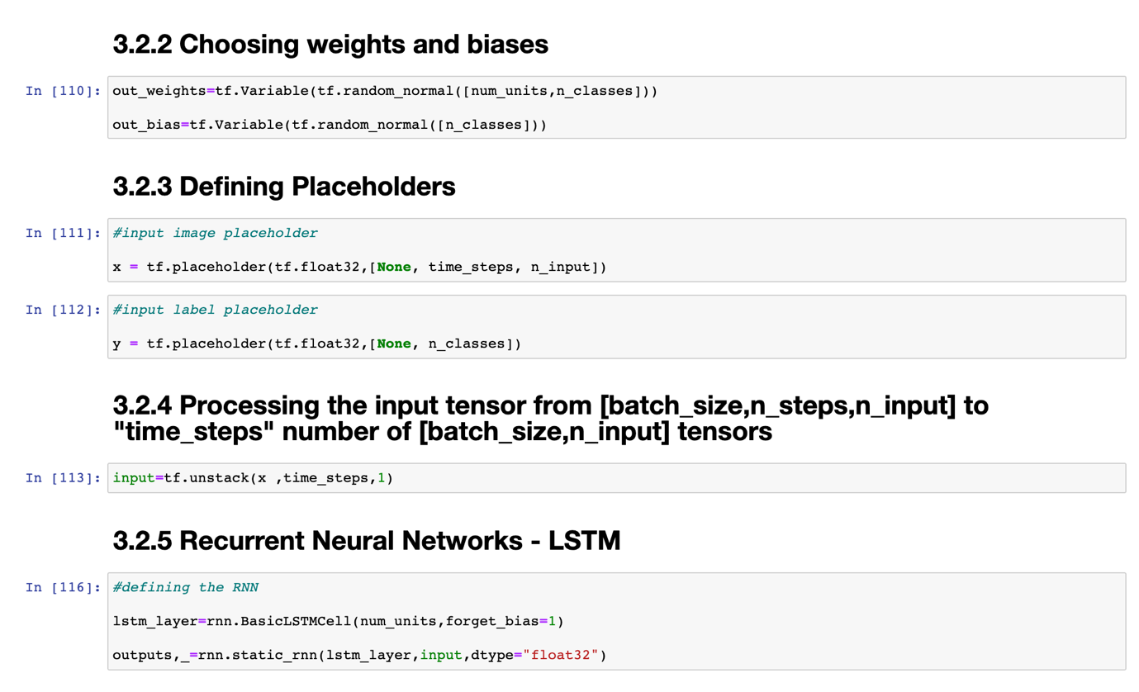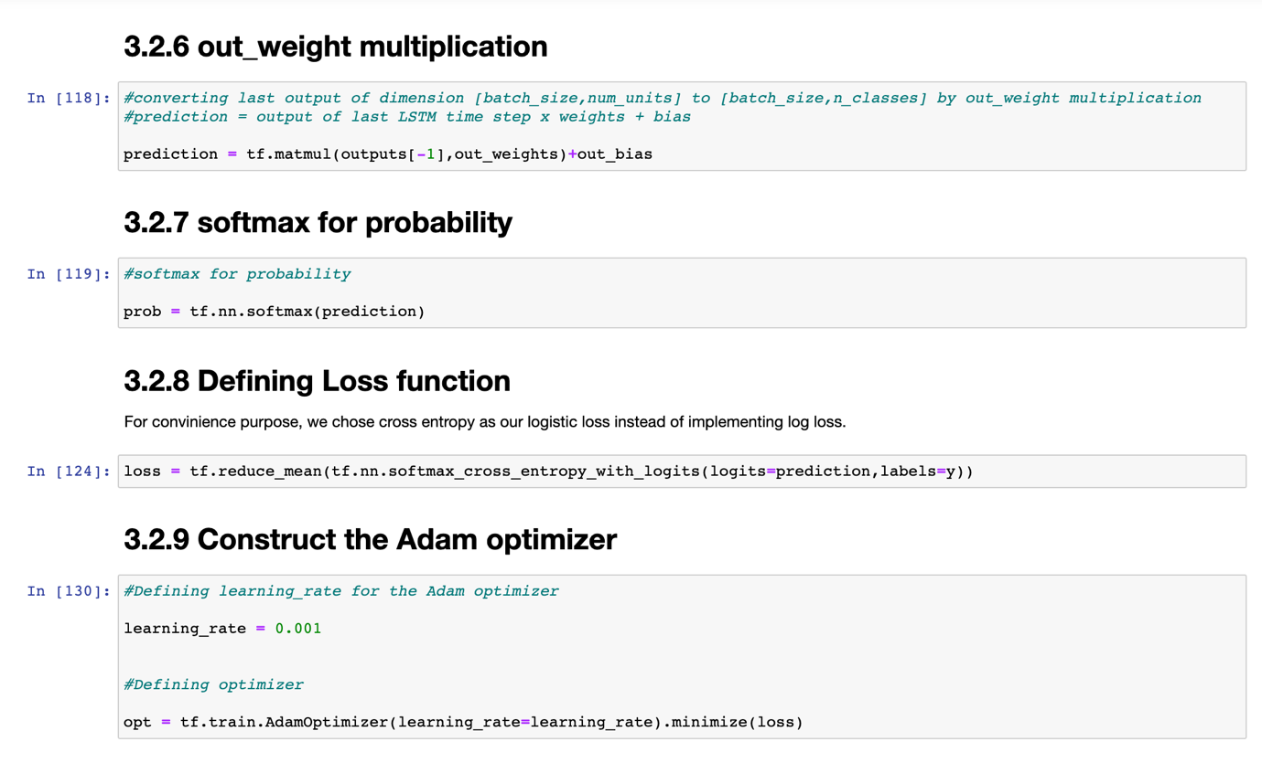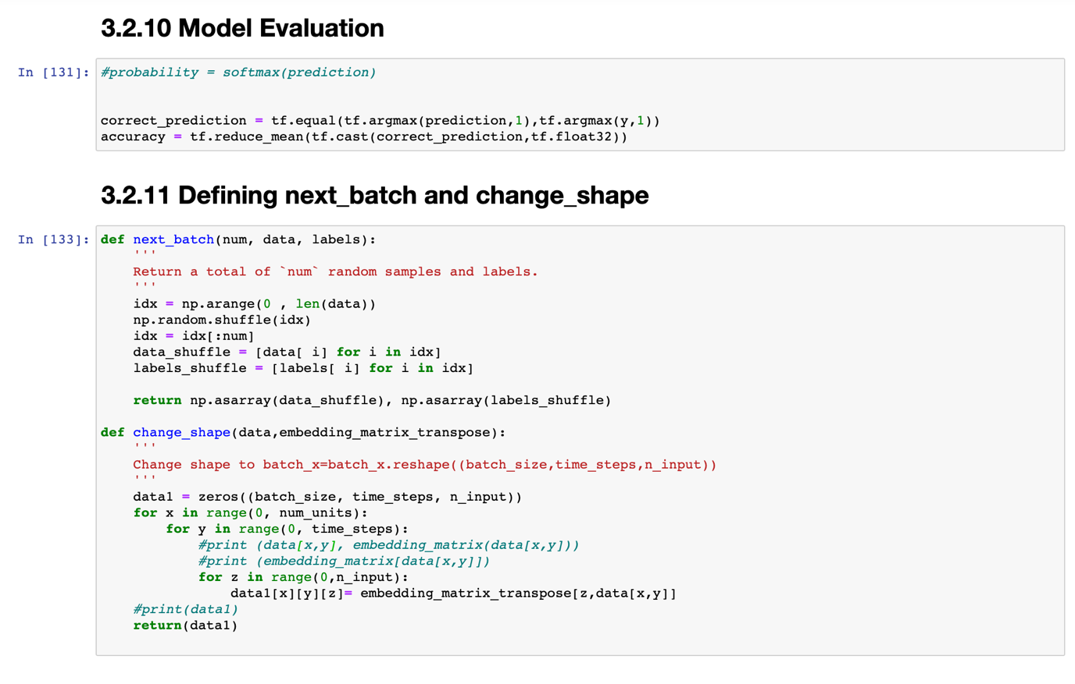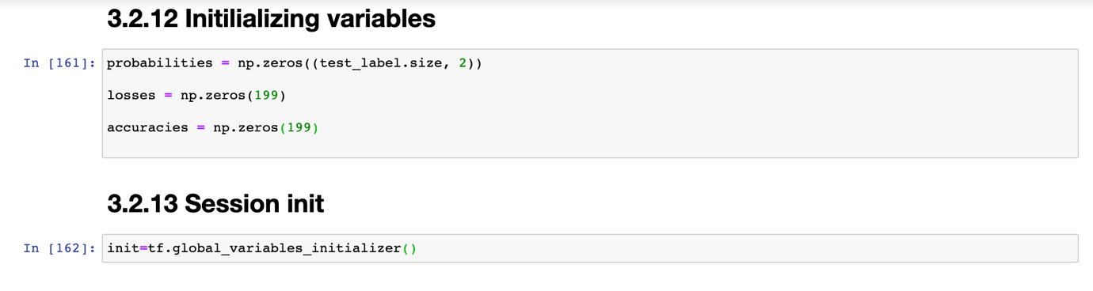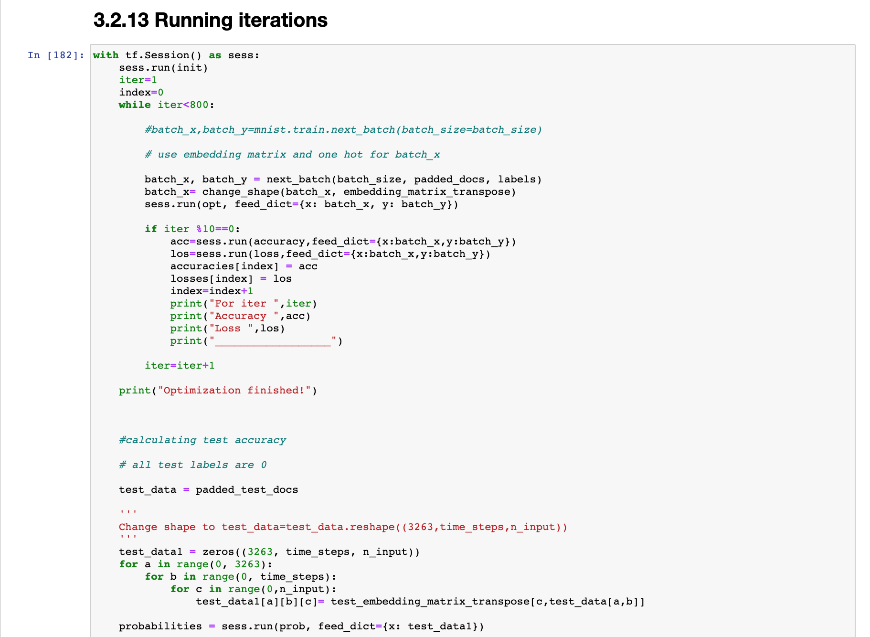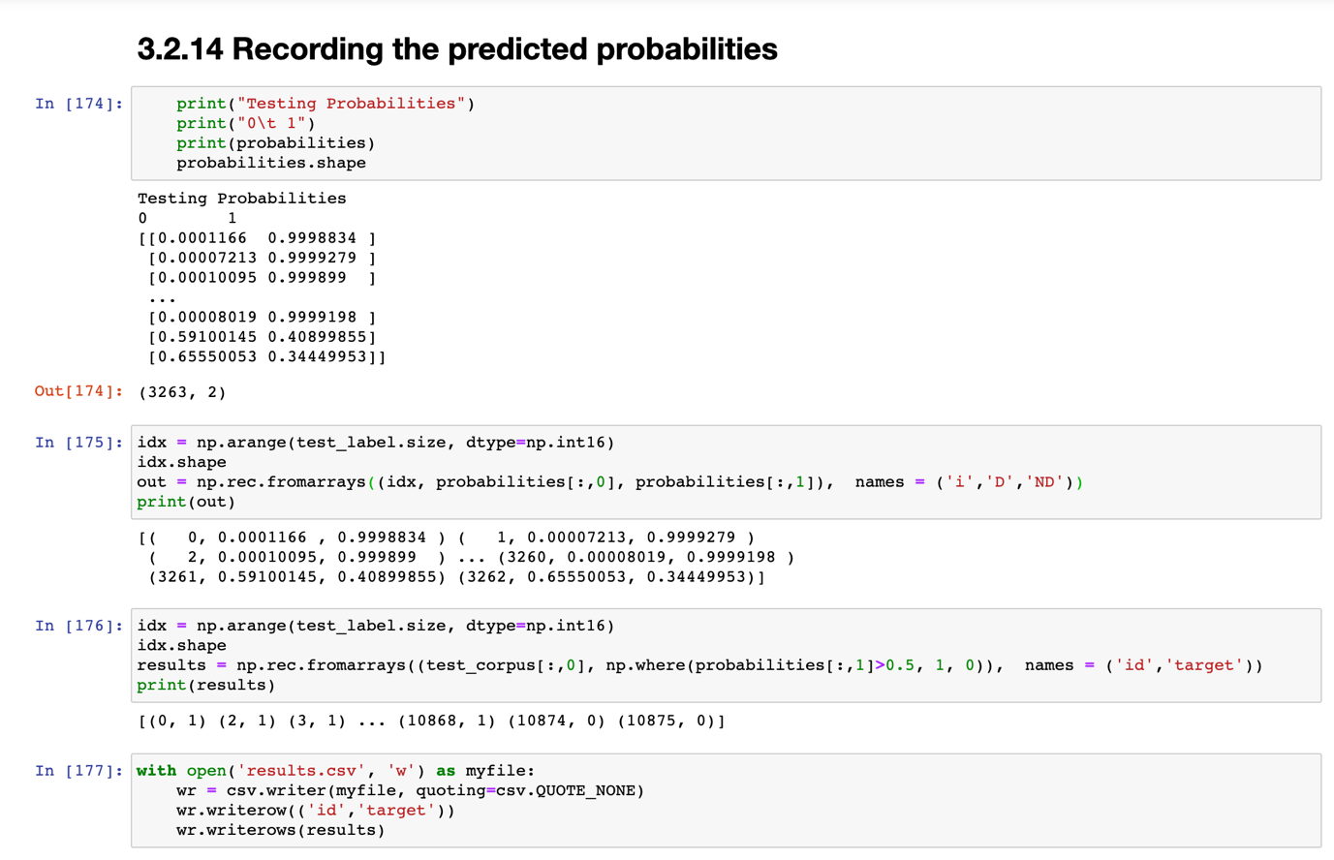

1. **Testing methodology/Accuracy testing**

We used three testing strategies as described below. We evaluating each of the strategy while validating the model. Below are some of the cases plotted.

1. **Log loss and Accuracy plots vs. Iterations in Training Data**

We used Training log loss and accuracy plot with the number of iterations. We could observe that as the number of iterations increased, the accuracy increased simultaneously, and the loss is lowered gradually. However, this could also lead to overfitting, as shown in the below cases. A note here is that we jotted down only some of the milestones in performance testing, for more readability and understanding.

We plotted this under each test case below:

Also, as part of the project testing, we uploaded our predicted values in Kaggle. Below are some of the bench marks of each step in building the algorithm.

1. When we used only 200 iterations, below are the observations.

Observations: It was too few iterations for the given training data set. And the model underwent Underfitting. Attached in the appendix, are the prediction details along with the Kaggle scoreboard.

We achieved only 0.68813 score on Kaggle.



1. When we used around 800 iterations, below are the observations.

Observations: It was too few iterations for the given training data set. And the model was optimal.



The below was initial score when batch size was 64 and 800 iterations were run.

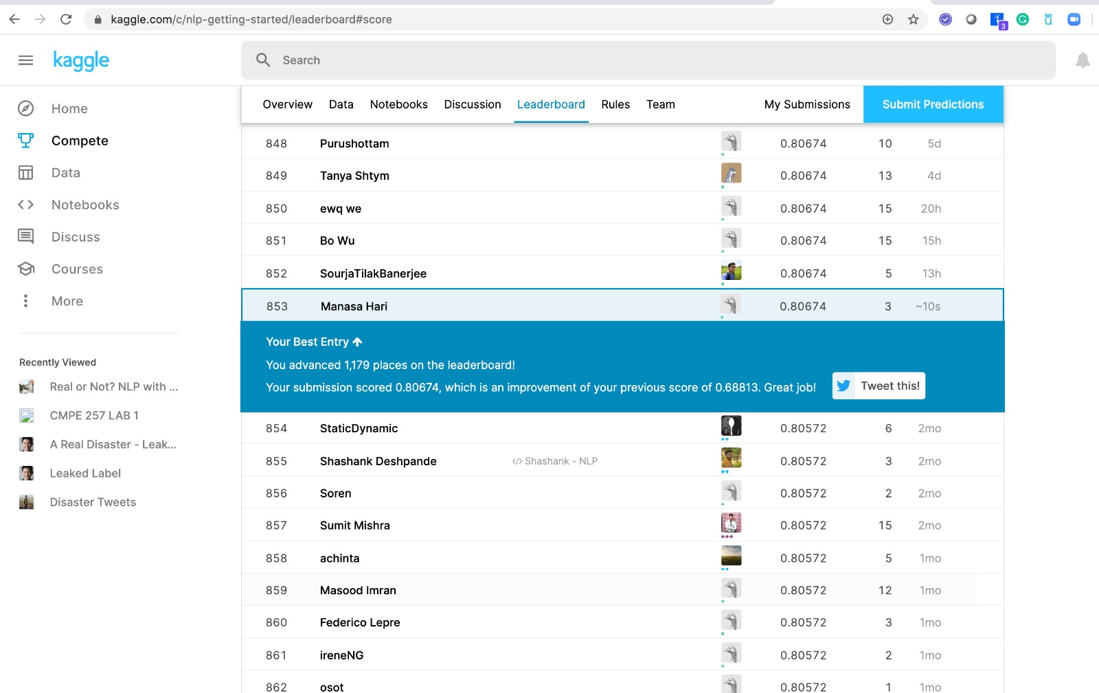

1. When we used around 2000 iterations, below are the observations.

Observations: It was too many iterations for the given training data set. It could well fit the training data but did not perform well in making predictions. And the model underwent overfitting. Attached in the appendix, are the prediction details along with the Kaggle scoreboard.

Kaggle score: 0.75971



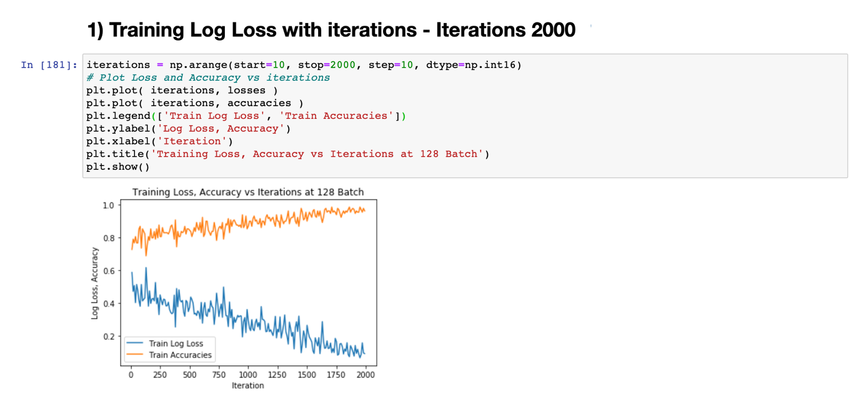

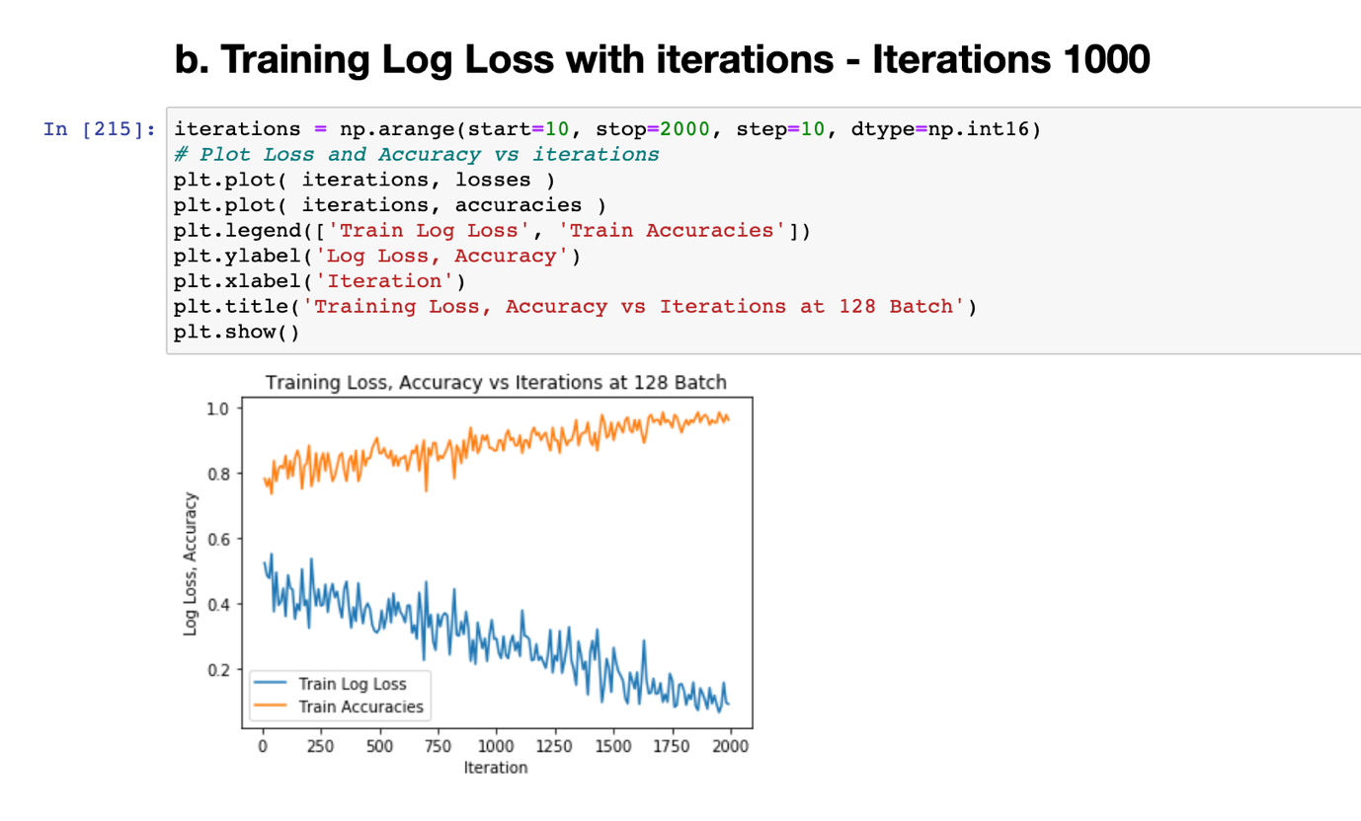

1. **Kaggle Score vs Optimization iterations**

We evaluated our model by varying iterations and finding out the Kaggle score. We plotted them below in a graph.

Below is the tabular representation of the score achieved by varying the number of iterations.



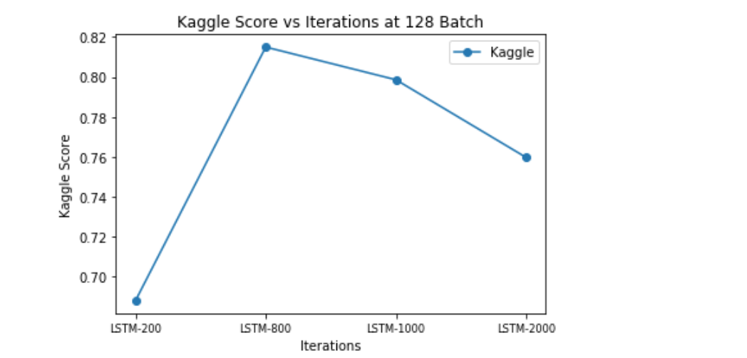

The plot represents that we achieved the best score when it is run 800 iterations. When we further increased the representation, it could have undergone overfitting and if it was lower than the optimal, it could have undergone underfitting.

1. **Test Scores vs Batch Size**

One very important parameter to evaluate the predicted values at each step is 'Batch size'. We calculate weights and biases accordingly. We evaluated our model by varying the batch size and the achieved Kaggle score with respect to each batch size. Dynamic RNNs, as opposed to the static RNNs used, allow dynamic batch sizes and take variable length inputs: a model that is more appropriate for variable length tweets.

Observation:

We could observe that when the batch size is 128, we could get an optimal score.

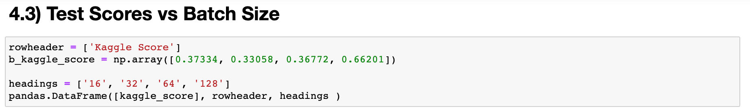

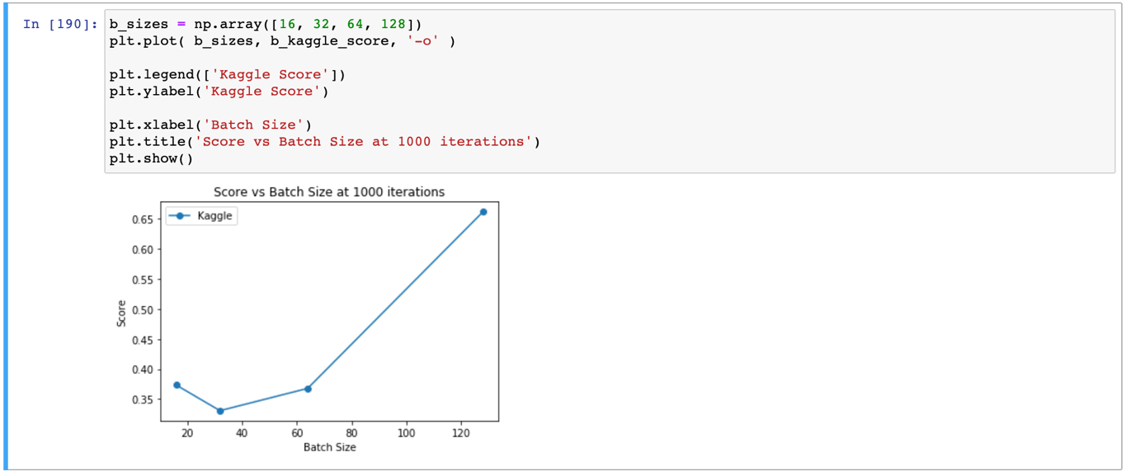

1. Result, conclusion, future work detailed description (10 pts)

Result:

As shown in the below picture, we achieved a reliable score of –

in the ongoing Kaggle competition.



Conclusion:

We could meticulously explore NLP using RNNs and the basic LSTM.

This project enabled us to explore the basic static LSTM and feed forward neural networks. We could classify a dataset of tweets into 'disaster related' and 'non-disaster related' classes. We used GloVe word vector based on Twitter corpus, in order to optimize the process. After that, we experimented by varying weight optimization iterations and LSTM input batch sizes to the test set scores. We compared the LSTM using a 10-fold cross validation model.

Future work:

Currently, we used the word embeddings as the base strategy. We want to further explore using locations, hyperlinks and keywords in building the RNN model.

CMPE-257 Project Developed in Spring 2020

—————————— ◆ ——————————

**References**

1. Data and Problem source: <https://www.kaggle.com/c/nlp-getting-started/data>.
2. Mittal, Aditi. “Understanding RNN and LSTM”. Oct 12, 2019. <https://towardsdatascience.com/understanding-rnn-and-lstm-f7cdf6dfc14e>
3. Phi, Michael. “Illustrated Guide to LSTM’s and GRU’s: A step by step explanation”. Sep 24, 2018. <https://towardsdatascience.com/illustrated-guide-to-lstms-and-gru-s-a-step-by-step-explanation-44e9eb85bf21>
4. <https://machinelearningmastery.com/prepare-text-data-deep-learning-keras/>
5. https://nlp.stanford.edu/projects/glove/
6. Géron, A. (2017). Hands-On Machine Learning with Scikit-Learn and TensorFlow: Concepts, Tools, and Techniques to Build Intelligent Systems. United States: O'Reilly Media.
7. <https://books.google.com/books?id=khpYDgAAQBAJ&pg=PA414&lpg=PA414&dq=Most+of+the+state-of-the-art+NLP+applications,+such+as+machine+translation,+automatic+summarization,+parsing,+sentiment+analysis&source=bl&ots=kLHAPJBlm-&sig=ACfU3U05nS0zBtDvZo_Cpt5PZIvzSqoaHA&hl=en&sa=X&ved=2ahUKEwiFuaWR1aDpAhUwHzQIHfkpDb8Q6AEwCnoECAsQAQ#v=onepage&q&f=false>

**Dataset and Description**

Link: <https://www.kaggle.com/c/nlp-getting-started/data>

1. Data format: Each sample in the train and test set has the following information:
2. The text of a tweet
3. A keyword from that tweet (although this may be blank!)
4. The location the tweet was sent from (may also be blank)
5. Files we have:
6. train.csv - the training set
7. test.csv - the test set
8. sample_submission.csv - a sample submission file in the correct format
9. Columns we use:
10. id - a unique identifier for each tweet
11. text - the text of the tweet
12. location - the location the tweet was sent from (may be blank)
13. keyword - a particular keyword from the tweet (may be blank)
14. target - in train.csv only, this denotes whether a tweet is about a real disaster (1) or not (0)
15. Output: We will predict whether a given tweet is about a real disaster or not. If so, predict a 1. If not, predict a 0.

**Technologies used:** Python, Keras, Tensorflow.

**Appendix**

**Predictions:**

|  |  |  |  |
| --- | --- | --- | --- |
|  | 0 | 0 | 0 |
|  | 0 | 0.1505156 | 0.8494844 |
|  | 1 | 0.09050537 | 0.9094946 |
|  | 2 | 0.015072056 | 0.984928 |
|  | 3 | 0.0039795944 | 0.9960204 |
|  | 4 | 0.01810527 | 0.9818948 |
|  | 5 | 0.34434786 | 0.65565217 |
|  | 6 | 0.91536677 | 0.084633164 |
|  | 7 | 0.88879395 | 0.11120602 |
|  | 8 | 0.7927213 | 0.20727876 |
|  | 9 | 0.86122763 | 0.13877234 |
|  | 10 | 0.8790129 | 0.12098707 |
|  | 11 | 0.8526885 | 0.14731154 |
|  | 12 | 0.85276455 | 0.14723547 |
|  | 13 | 0.8664383 | 0.13356169 |
|  | 14 | 0.86926454 | 0.13073544 |
|  | 15 | 0.91398925 | 0.08601075 |
|  | 16 | 0.6973401 | 0.30265993 |
|  | 17 | 0.48740608 | 0.51259387 |
|  | 18 | 0.90057504 | 0.099424995 |
|  | 19 | 0.8963903 | 0.10360971 |
|  | 20 | 0.7162792 | 0.28372073 |
|  | 21 | 0.74825865 | 0.25174132 |
|  | 22 | 0.88079435 | 0.11920561 |
|  | 23 | 0.6161239 | 0.38387606 |
|  | 24 | 0.791695 | 0.208305 |
|  | 25 | 0.8442739 | 0.15572602 |
|  | 26 | 0.90055424 | 0.099445716 |
|  | 27 | 0.7927861 | 0.20721382 |
|  | 28 | 0.8518568 | 0.14814316 |
|  | 29 | 0.027026983 | 0.97297305 |
|  | 30 | 0.84411454 | 0.15588543 |
|  | 31 | 0.78474003 | 0.21526 |
|  | 32 | 0.86785036 | 0.13214958 |
|  | 33 | 0.38570628 | 0.6142937 |
|  | 34 | 0.0017570416 | 0.998243 |
|  | 35 | 0.9125669 | 0.08743304 |
|  | 36 | 0.46324474 | 0.53675526 |
|  | 37 | 0.75315607 | 0.24684389 |
|  | 38 | 0.8243213 | 0.17567864 |
|  | 39 | 0.014520138 | 0.9854799 |
|  | 40 | 0.85757434 | 0.14242563 |
|  | 41 | 0.15367855 | 0.84632146 |
|  | 42 | 0.61276424 | 0.38723567 |
|  | 43 | 0.4745252 | 0.5254747 |
|  | 44 | 0.8907204 | 0.109279625 |
|  | 45 | 0.3176081 | 0.6823919 |
|  | 46 | 0.9421273 | 0.05787269 |
|  | 47 | 0.9461451 | 0.053854868 |

**Results:**

|  |  |  |
| --- | --- | --- |
|  | id | target |
|  | 0 | 1 |
|  | 2 | 1 |
|  | 3 | 1 |
|  | 9 | 1 |
|  | 11 | 1 |
|  | 12 | 1 |
|  | 21 | 0 |
|  | 22 | 0 |
|  | 27 | 0 |
|  | 29 | 0 |
|  | 30 | 0 |
|  | 35 | 0 |
|  | 42 | 0 |
|  | 43 | 0 |
|  | 45 | 0 |
|  | 46 | 0 |
|  | 47 | 0 |
|  | 51 | 1 |
|  | 58 | 0 |
|  | 60 | 0 |
|  | 69 | 0 |
|  | 70 | 0 |
|  | 72 | 0 |
|  | 75 | 0 |
|  | 84 | 0 |
|  | 87 | 0 |
|  | 88 | 0 |
|  | 90 | 0 |
|  | 94 | 0 |
|  | 99 | 1 |
|  | 101 | 0 |
|  | 103 | 0 |
|  | 106 | 0 |
|  | 108 | 1 |
|  | 111 | 1 |
|  | 115 | 0 |
|  | 116 | 1 |
|  | 122 | 0 |
|  | 123 | 0 |
|  | 124 | 1 |
|  | 125 | 0 |
|  | 127 | 1 |
|  | 140 | 0 |
|  | 142 | 1 |
|  | 147 | 0 |
|  | 148 | 1 |
|  | 150 | 0 |
|  | 152 | 0 |

**Probabilities:**

For iter 10

Accuracy 0.8046875

Loss 0.50922424

__________________

For iter 20

Accuracy 0.796875

Loss 0.4614792

__________________

For iter 30

Accuracy 0.8203125

Loss 0.40784174

__________________

For iter 40

Accuracy 0.7734375

Loss 0.4762222

__________________

For iter 50

Accuracy 0.8046875

Loss 0.42260525

__________________

For iter 60

Accuracy 0.7890625

Loss 0.44487348

__________________

For iter 70

Accuracy 0.8125

Loss 0.45680463

__________________

For iter 80

Accuracy 0.8203125

Loss 0.4178124

__________________

For iter 90

Accuracy 0.765625

Loss 0.47575513

__________________

For iter 100

Accuracy 0.8515625

Loss 0.33627287

__________________

For iter 110

Accuracy 0.78125

Loss 0.5046478

__________________

For iter 120

Accuracy 0.796875

Loss 0.49587548

__________________

For iter 130

Accuracy 0.84375

Loss 0.35237136

__________________

For iter 140

Accuracy 0.875

Loss 0.37459505

__________________

For iter 150

Accuracy 0.859375

Loss 0.34797686

__________________

For iter 160

Accuracy 0.8515625

Loss 0.40814596

__________________

For iter 170

Accuracy 0.828125

Loss 0.353389

__________________

For iter 180

Accuracy 0.8125

Loss 0.48322877

__________________

For iter 190

Accuracy 0.8359375

Loss 0.4301808

__________________

For iter 200

Accuracy 0.8125

Loss 0.42958814

__________________

For iter 210

Accuracy 0.8671875

Loss 0.3825365

__________________

For iter 220

Accuracy 0.8828125

Loss 0.3277074

__________________

For iter 230

Accuracy 0.859375

Loss 0.35490602

__________________

For iter 240

Accuracy 0.8359375

Loss 0.40459144

__________________

For iter 250

Accuracy 0.8203125

Loss 0.4415267

__________________

For iter 260

Accuracy 0.8125

Loss 0.41012534

__________________

For iter 270

Accuracy 0.8671875

Loss 0.32890195

__________________

For iter 280

Accuracy 0.8203125

Loss 0.43306082

__________________

For iter 290

Accuracy 0.8671875

Loss 0.3210754

__________________

For iter 300

Accuracy 0.8203125

Loss 0.42362547

__________________

For iter 310

Accuracy 0.8125

Loss 0.39847904

__________________

For iter 320

Accuracy 0.8671875

Loss 0.34221205

__________________

For iter 330

Accuracy 0.828125

Loss 0.40324652

__________________

For iter 340

Accuracy 0.859375

Loss 0.36731666

__________________

For iter 350

Accuracy 0.7421875

Loss 0.5234597

__________________

For iter 360

Accuracy 0.8125

Loss 0.40690982

__________________

For iter 370

Accuracy 0.8125

Loss 0.428889

__________________

For iter 380

Accuracy 0.8671875

Loss 0.35530594

__________________

For iter 390

Accuracy 0.875

Loss 0.31927136

__________________

For iter 400

Accuracy 0.8046875

Loss 0.43344277

__________________

For iter 410

Accuracy 0.8671875

Loss 0.31188732

__________________

For iter 420

Accuracy 0.8125

Loss 0.38951474

__________________

For iter 430

Accuracy 0.828125

Loss 0.40016627

__________________

For iter 440

Accuracy 0.78125

Loss 0.46216962

__________________

For iter 450

Accuracy 0.859375

Loss 0.35073376

__________________

For iter 460

Accuracy 0.8359375

Loss 0.413001

__________________

For iter 470

Accuracy 0.8125

Loss 0.38684937

__________________

For iter 480

Accuracy 0.7734375

Loss 0.48281783

__________________

For iter 490

Accuracy 0.8046875

Loss 0.47355783

__________________

For iter 500

Accuracy 0.828125

Loss 0.34480453

__________________

For iter 510

Accuracy 0.8046875

Loss 0.44361097

__________________

For iter 520

Accuracy 0.84375

Loss 0.35121757

__________________

For iter 530

Accuracy 0.8125

Loss 0.38925427

__________________

For iter 540

Accuracy 0.90625

Loss 0.34675968

__________________

For iter 550

Accuracy 0.8125

Loss 0.41969198

__________________

For iter 560

Accuracy 0.84375

Loss 0.3851005

__________________

For iter 570

Accuracy 0.859375

Loss 0.35212684

__________________

For iter 580

Accuracy 0.8046875

Loss 0.41215682

__________________

For iter 590

Accuracy 0.8359375

Loss 0.34320468

__________________

For iter 600

Accuracy 0.7890625

Loss 0.4188121

__________________

For iter 610

Accuracy 0.84375

Loss 0.38491297

__________________

For iter 620

Accuracy 0.8515625

Loss 0.36662343

__________________

For iter 630

Accuracy 0.90625

Loss 0.31803682

__________________

For iter 640

Accuracy 0.8203125

Loss 0.40634412

__________________

For iter 650

Accuracy 0.8359375

Loss 0.3846455

__________________

For iter 660

Accuracy 0.8359375

Loss 0.34824216

__________________

For iter 670

Accuracy 0.859375

Loss 0.31586075

__________________

For iter 680

Accuracy 0.8359375

Loss 0.42279512

__________________

For iter 690

Accuracy 0.8671875

Loss 0.3291077

__________________

For iter 700

Accuracy 0.8671875

Loss 0.3270688

__________________

For iter 710

Accuracy 0.859375

Loss 0.3034977

__________________

For iter 720

Accuracy 0.828125

Loss 0.3483694

__________________

For iter 730

Accuracy 0.78125

Loss 0.43891728

__________________

For iter 740

Accuracy 0.875

Loss 0.36716694

__________________

For iter 750

Accuracy 0.8671875

Loss 0.34643334

__________________

For iter 760

Accuracy 0.8515625

Loss 0.36824173

__________________

For iter 770

Accuracy 0.7734375

Loss 0.4055602